BlueWeb Runbook
Validating Scheduled Jobs After a Restart
Liferay DXP 7.4 • PROD • mdcpappblw11lv / mdcpappblw12lv • Baseline 2026-09-02
After a restart, patch, or deploy, the scheduled jobs need to be confirmed healthy. Only LDAP Sync runs often enough to simply watch — the others run once a day, so this document covers what to check and where to look.

1. Jobs and baseline
Captured from PROD on 2026-09-02. Runtimes are from the last 120 log rows, excluding sub-100 ms cluster back-off entries. Use these figures to spot drift after a restart — a job finishing far faster than its average usually means it processed nothing.
Job | Trigger ID | Schedule | Avg runtime | Log file
LDAP Sync | 219121732 | Every 5 min | 7.8 s | ldap-dbsync-service.log
LMS LISTS Scheduler | 218678601 | Daily 12:00 AM | 11.0 s | lms-lists-service.log
NAVEX SFTP Scheduler | 219376252 | Daily 1:00 AM | 7.2 s | navex-sftp-service.log
COI Workday Feed | 217948276 | Daily 1:00 AM | 0.8 s | coi-workday-service.log
LMS FTP Scheduler | 217947562 | Daily 1:00 AM | 13.5 s | lms-ftp-service.log
Licensee Data Feed | 217927124 | Daily 1:00 AM | 1.2 s | coi-service.log (confirm)
Review Journal Article | 217940118 | Daily 4:00 AM | disabled | —
Blueweb Document Expiry | 217940117 | Daily 4:00 AM UTC | disabled | —
All active jobs: Cluster Mode = All Nodes, Overlap Allowed unchecked, America/Chicago (except Blueweb Document Expiry, which is UTC). The two disabled jobs have never run — confirm with the team whether that is intentional.
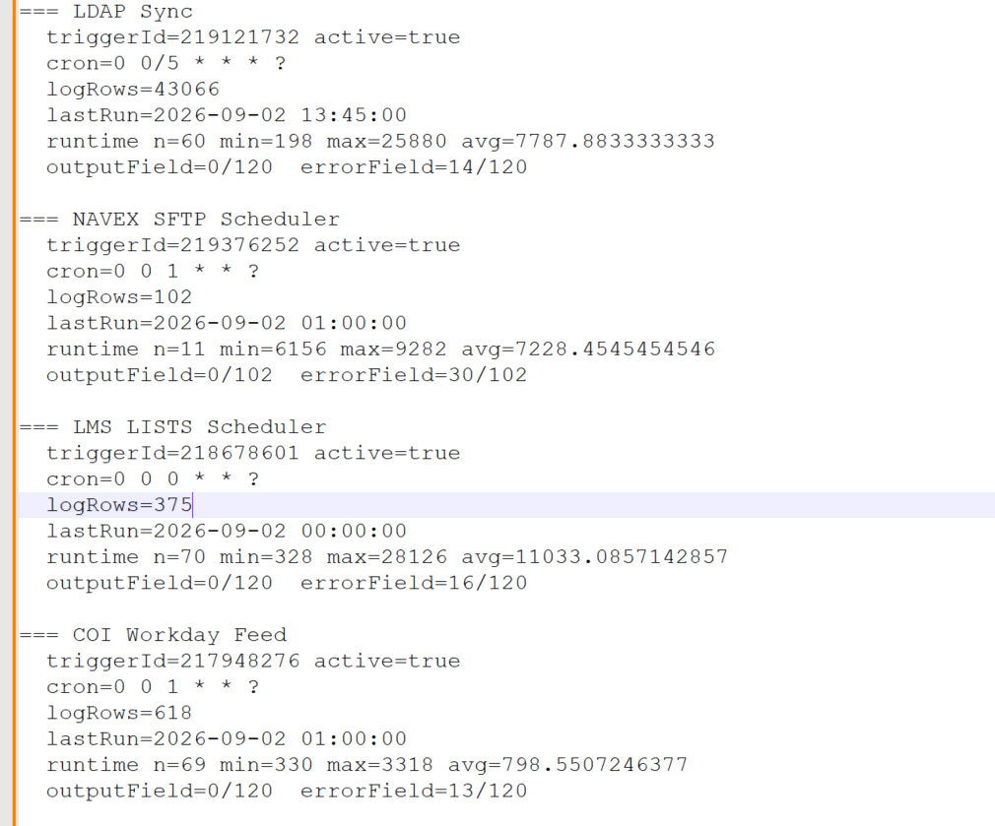
Figure 1 — Health check output — LDAP Sync, NAVEX SFTP, LMS LISTS and COI Workday Feed.
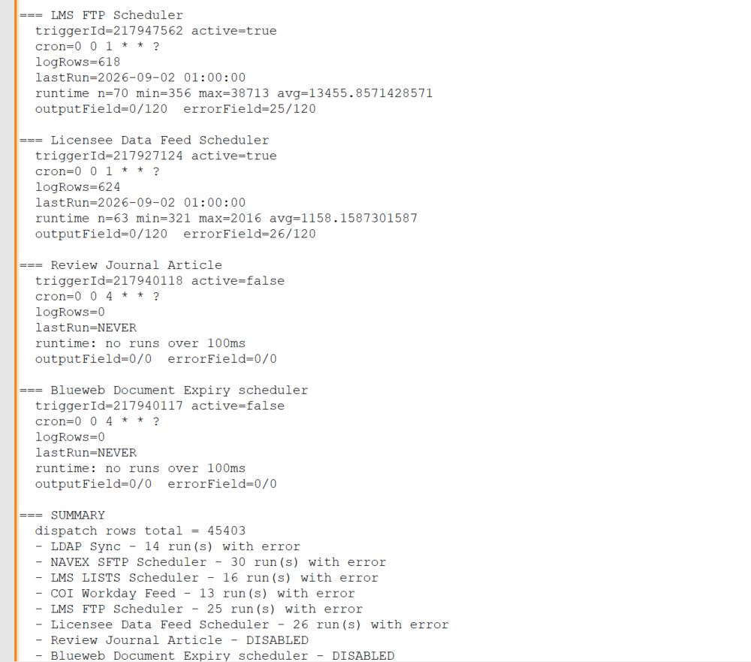
Figure 2 — Health check output — LMS FTP, Licensee Data Feed, the two disabled jobs, and the summary.

2. Per-job log files
Each job writes to its own file under $CATALINA_BASE/logs, separate from catalina.out. Files rotate daily and older days are gzipped. The modification time alone tells you whether a job ran on schedule.
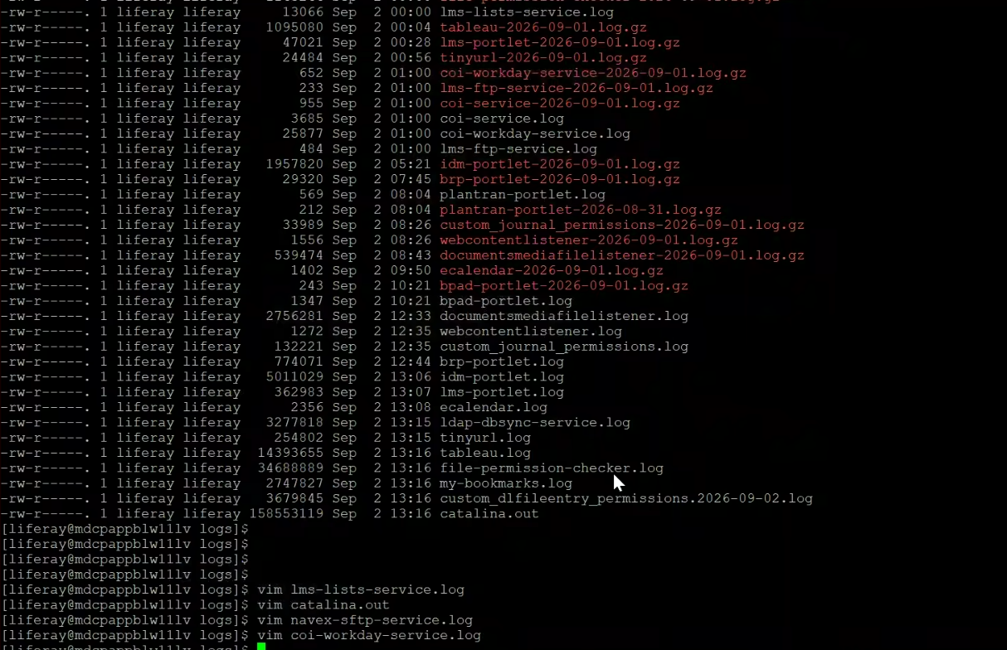
Figure 3 — Log directory on mdcpappblw11lv. Note the timestamps: lms-lists-service.log at 00:00, the three 1:00 AM feeds at 01:00, ldap-dbsync-service.log continuously updated.
cd $CATALINA_BASE/logs
ls -la ldap-dbsync-service.log lms-lists-service.log \
coi-workday-service.log lms-ftp-service.log \
navex-sftp-service.log coi-service.log

# read today
tail -50 lms-lists-service.log

# read a rotated day
zcat lms-lists-service-2026-09-01.log.gz | tail -50
Pass criteria: each timestamp matches that job's scheduled time for the current day. A file dated yesterday means the job has not run since.
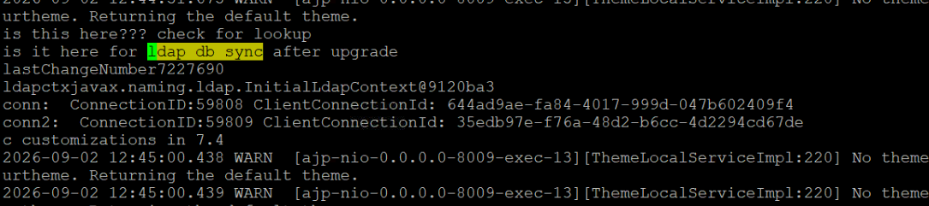
Figure 4 — LDAP Sync writing normally — the changelog position (lastChangeNumber) advances on each run.
Check both nodes. Only the node that won the cluster lock writes output; the other will show an older timestamp. That is expected.

3. Health check script
Run in Control Panel → Server Administration → Script (Groovy). Read-only and safe in PROD. Covers every trigger in one pass.
import com.liferay.dispatch.service.*
import java.text.SimpleDateFormat

def fmt = new SimpleDateFormat("yyyy-MM-dd HH:mm:ss")
def problems = []
int totalRows = 0

for (t in DispatchTriggerLocalServiceUtil.getDispatchTriggers(-1, -1)) {
long id = t.getDispatchTriggerId()
def logs = DispatchLogLocalServiceUtil.getDispatchLogs(id, 0, 120)
int rows = DispatchLogLocalServiceUtil.getDispatchLogsCount(id)
totalRows = totalRows + rows

def done = logs.findAll { it.getEndDate() != null }
def open = logs.findAll { it.getEndDate() == null }
def last = done.isEmpty() ? null : done.get(0)

def durs = []
for (l in done) {
long ms = l.getEndDate().getTime() - l.getStartDate().getTime()
if (ms > 100) durs.add(ms)
}

out.println("=== " + t.getName())
out.println(" triggerId=" + id + " active=" + t.isActive())
out.println(" cron=" + t.getCronExpression())
out.println(" logRows=" + rows)
out.println(" lastRun=" + (last == null ? "NEVER"
: fmt.format(last.getStartDate())))
if (!durs.isEmpty()) {
long sum = 0
for (dv in durs) sum = sum + dv
out.println(" runtime n=" + durs.size() + " min=" + durs.min()
+ " max=" + durs.max() + " avg=" + (sum / durs.size()))
} else {
out.println(" runtime: no runs over 100ms")
}

if (!open.isEmpty()) {
out.println(" *** STUCK: " + open.size() + " open row(s) ***")
for (l in open) out.println(" logId=" + l.getDispatchLogId()
+ " start=" + fmt.format(l.getStartDate()))
problems.add(t.getName() + " - STUCK")
}
if (!t.isActive()) problems.add(t.getName() + " - DISABLED")
out.println("")
}

out.println("=== SUMMARY")
out.println(" dispatch rows total = " + totalRows)
if (problems.isEmpty()) out.println(" No problems detected.")
else for (pr in problems) out.println(" - " + pr)

What to check in the output
Field | Healthy | Action if not
STUCK line | Absent | Follow the stuck-job runbook — delete the open DispatchLog row
active | true for the 6 active jobs | Re-enable; a restart may have left it off
lastRun | Within the job's interval | Job has not fired — investigate
runtime avg | Close to the baseline in section 1 | Far below baseline means it processed nothing

4. Watch out for
- Deactivate LDAP Sync before a planned restart and reactivate afterwards. Stopping the JVM mid-run leaves an orphaned log record that blocks every subsequent fire — this caused the August outage.
- Avoid restarting between 11:45 PM and 1:15 AM. Five active jobs fire in that window, four of them at 1:00 AM together.
- A Successful status does not mean a clean run. The LMS LISTS run on 2026-09-02 recorded Successful with a 13-second runtime while its log showed repeated NullPointerExceptions (Contacts.getContactUID() returning null in addSubscribersToList). The exceptions are caught per record, so failed subscribers are skipped and the job still reports success. Always pair the status check with the job's own log file.
- Do not use "Run Now" on the FTP, SFTP, or data feed jobs to validate them. They push real files to external systems and a manual trigger can send a duplicate or out-of-cycle transfer. Run Now is safe for LDAP Sync, which only reads the directory changelog.
- Smoke-test the LMS page on both nodes after a restart. The LMS portlet failure after Java patching produced no bad job record at all — it only appeared when the page was opened.

Known gaps
- No job populates the DispatchLog output field (0 of 120 rows for every job). Liferay provides this field for a run summary; using it for a record count would make validation a single query instead of a log check across two nodes.
- NAVEX SFTP has 11 runs that failed with com/jcraft/jsch/JSch — the JSch SFTP library missing from the classpath, so no transfer took place. Eight were manual Run Now invocations; three were scheduled runs (2026-07-27, 2026-07-30 and 2026-08-15). This predates the Tomcat upgrade. The likely cause is the JSch jar being present on one node and missing on the other; compare with: find $CATALINA_BASE -name "*jsch*" on both nodes.
- Error-field entries on LDAP Sync were checked and are all the expected cluster back-off message, not faults. The remaining feeds have not been checked.
- LDAP Sync holds 43,066 of the 45,403 dispatch log rows. There is no retention policy on this table — worth adding before it grows further.
- Review Journal Article and Blueweb Document Expiry are disabled and have never run. Confirm whether that is intended.

